

Table of Contents
Introduction and Assumptions 3
Main Assumptions 3
Task 1: Functional Network Design 3
Task 1a: Service Classification and Traffic Analysis 3
Service Profile Table 5
Task 1b: Physical Network Architecture and Equipment Specification 5
Tech & Co – Overall Network Architecture 6
Tech & Co – Backbone Network Design 7
Bandwidth Summary 7
Tech & Co – Floor & Warehouse Network layout 8
Network Equipment Specification 9
Task 2: Network Restructuring Plan 10
Tech & Co – Remote Connectivity Model 10
2.1 Computing Infrastructure Minimization 11
2.2 Revised Onsite Infrastructure 11
Tech & Co – Minimized On-Site Infrastructure 12
2.3 Implementation Action Plan (Source: Tanenbaum and Wetherall, 2011) 13
Task 3: Final Network Design and Cost Evaluation 14
Tech & Co – Remote Connectivity Model 14
Detailed Cost Breakdown 15
Total Cost of Ownership (TCO) Analysis 16
Task 4: Risk-Benefit Analysis and Return on Investment 17
4.1 Technical Threats 17
4.2 Threats to the Business 17
4.3 Key benefit 17
4.4 ROI Analysis 17
References 18

Introduction and Assumptions
This report outlines a plan to upgrade Tech & Co.’s IT systems. The goal is to help the business double its turnover moving from £4 million to £8 million without losing that 20% profit margin. Supporting permanent remote work and high-quality customer service ensures strategic competitive advantage (Kashyap and Verma, 2023). This report includes details on the network layout, a cost breakdown, and an analysis of potential risks and benefits.

Main Assumptions
- Staff: About 100 on-site employees and 135 remote workers will be required.
- Systems: As most services will operate on Microsoft Azure, the ERP system will remain on-site.
- Security: A secure VPN will be used to connect all remote employees.
- Users will require between 25 and 80 Mbps of internet speed depending on their tasks

Task 1: Functional Network Design

Task 1a: Service Classification and Traffic Analysis

There are four types of network services: voice, data, video, and multimedia services. Classification ensures Quality of Service (QoS) by prioritizing critical traffic above non-critical backups (Lammle, 2021). Voice services and video services have been given precedence over others owing to their sensitivity to delays. Figure 1 illustrates the service mapping and traffic flows from external to internal systems. The segregation between inbound services and outbound services has been done to better manage bandwidth and firewalls.

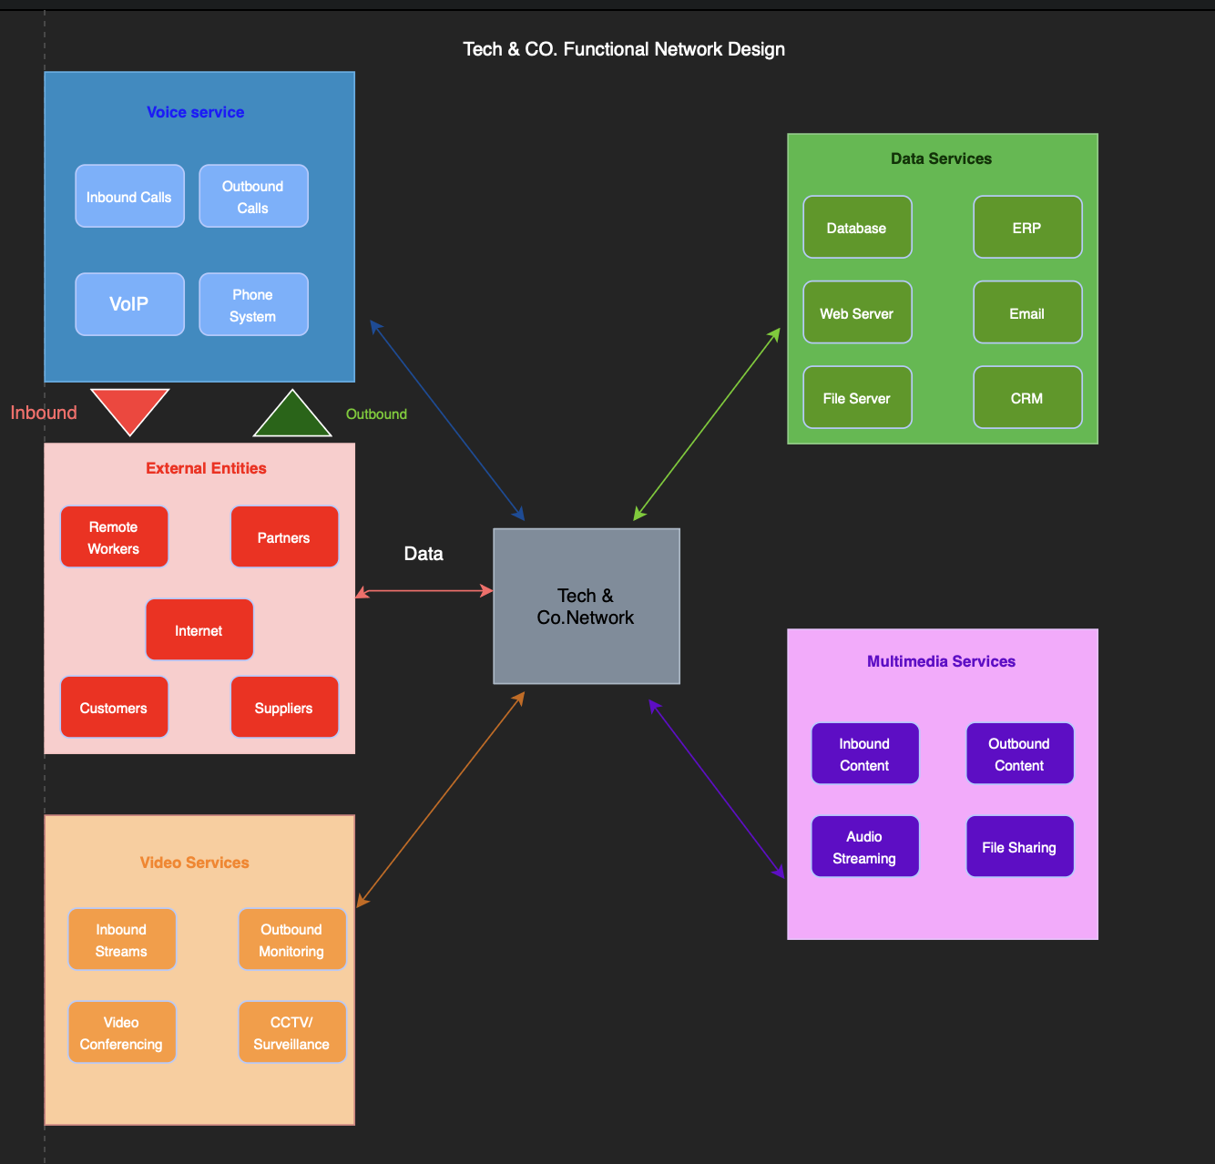

Figure 1. Functional Network Design - Service Classification and Traffic Flow

Service Profile Table
Table 1 specifies service characteristics derived from ITU-T and enterprise best practices (Cisco Systems, 2024a).

Service | Class | Direction | Bandwidth | Latency | Availability
VoIP Calls | Voice | Inbound/Outbound | 64-100 kbps/call | <150 ms | 99.99%
IP PBX/SIP Trunk | Voice | Inbound/Outbound | 2-5 Mbps aggregate | <100 ms | 99.99%
Email (SMTP/IMAP) | Data | Inbound/Outbound | 5-20 Mbps | <500 ms | 99.99%
ERP System | Data | Internal | 50 – 100 Mbps | <50 ms | 99.99%
CRM / Sales Platform | Data | Outbound | 20 – 50 Mbps | <100 ms | 99.99%
Web Server/  E-commerce | Data | Inbound | 100 -500 Mbps | <200 ms | 99.99%
Database Queries | Data | Internal | 100-200 Mbps | <20 ms | 99.99%
Video Conferencing | Video | Outbound | 2-6 Mbps/call | <150 ms | 99.99%
CCTV/  Surveillance | Video | Internal | 2-4 Mbps/ camera | <200ms | 99.95%
Audio Streaming | Multimedia | Inbound | 128-320 kbps/stream | <500 ms | 99.90%
File Sharing / Backup | Multimedia | Internal/Outbound | 50-200 Mbps | <1s | 99.90%

Table 1. Service Profile - Technical Characteristics

Task 1b: Physical Network Architecture and Equipment Specification
The network uses the Cisco three-tiered design (core, distribution, access) (Oppenheimer, 2010). Core devices on Floor 2 house the server cluster and core switches, with fast backbone connections. Distribution switches perform routing functions, separating traffic by departments.
There are 50 wireless access points in the access layer. Refer to Figures 2-4 for illustrations of the physical network design. Such a structure ensures scalability and high availability with redundancy.

Tech & Co – Overall Network Architecture
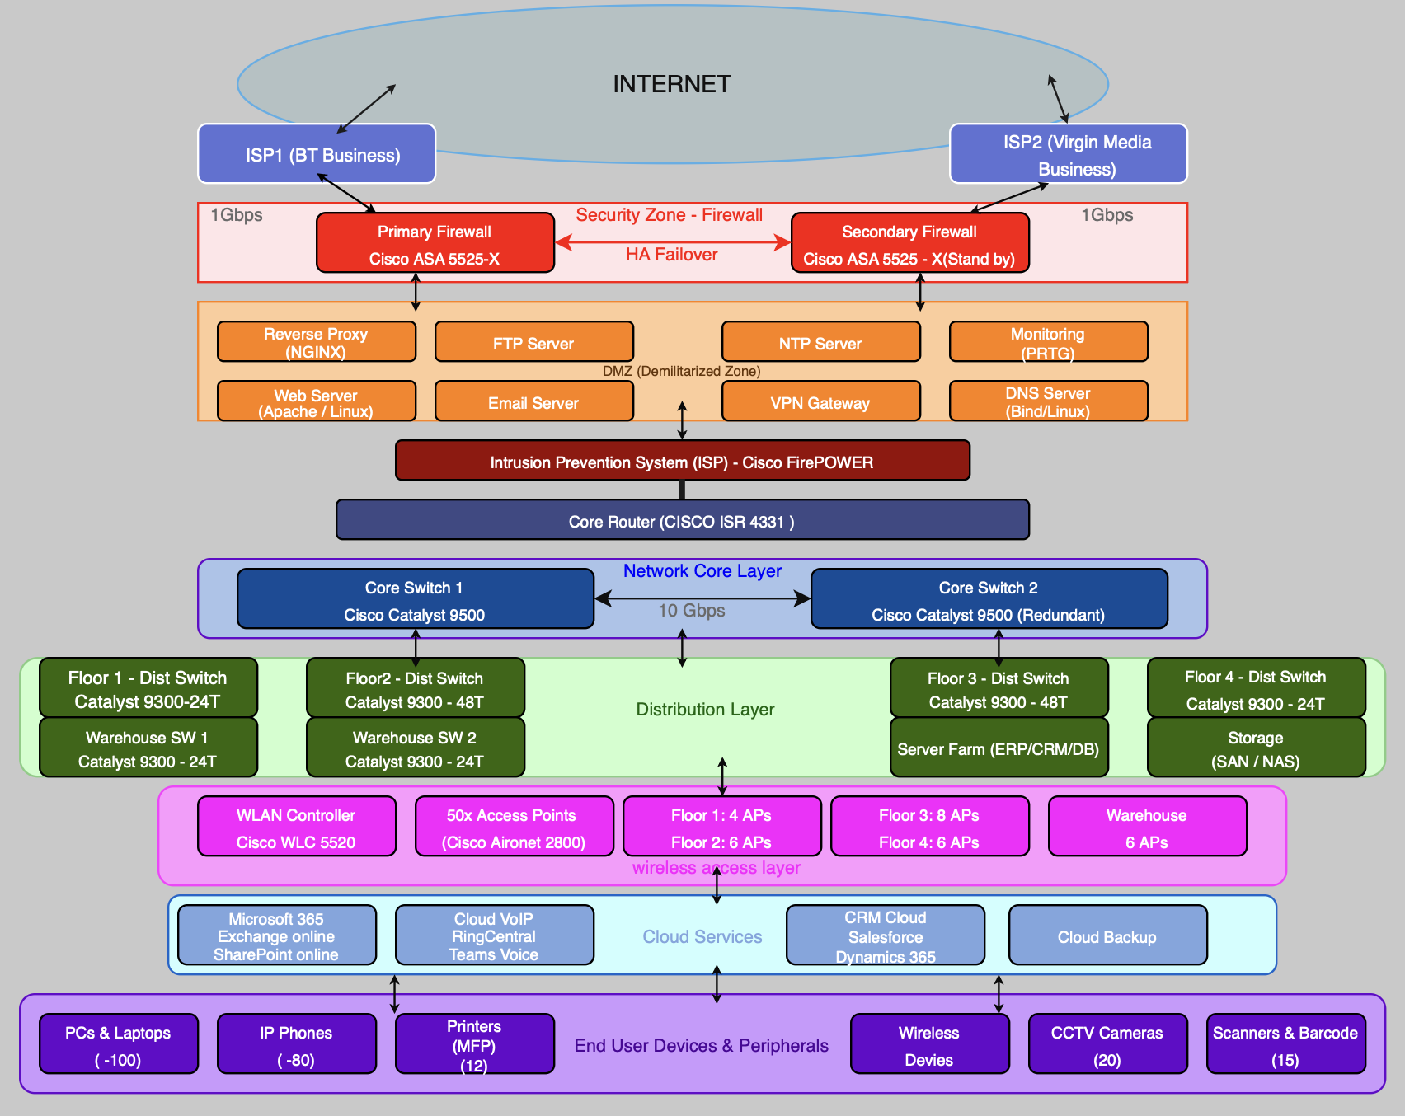

Figure 2. Overall Network Architecture - Internet Connectivity, Security, Core Infrastructure

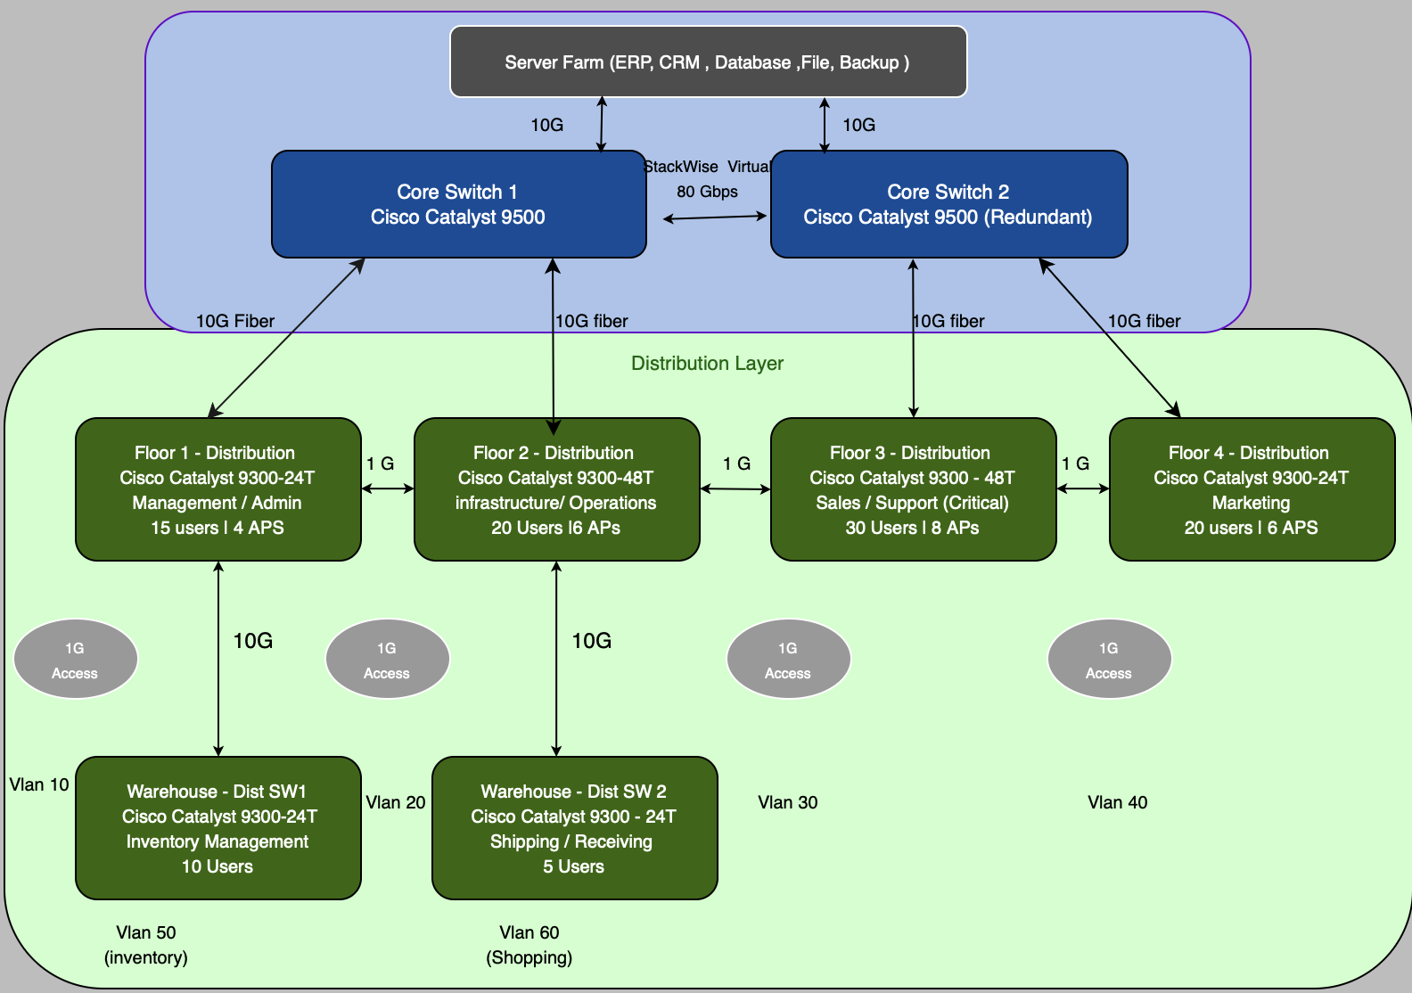
Tech & Co – Backbone Network Design

Figure 3. Backbone Network - Core and Distribution Switch Topology with 10 Gbps Fiber Uplinks

Bandwidth Summary
Core to Distribution: 10 Gbps Fiber (Dual Uplinks per Switch)
Distribution to Access: 1 Gbps Copper (Cat6A) | Core Stack: 80 Gbps Stack Wise Virtual
Inter-Distribution: 1 Gbps Redundant links | Server Farm: 10 Gbps Dual Uplinks

Tech & Co – Floor & Warehouse Network layout
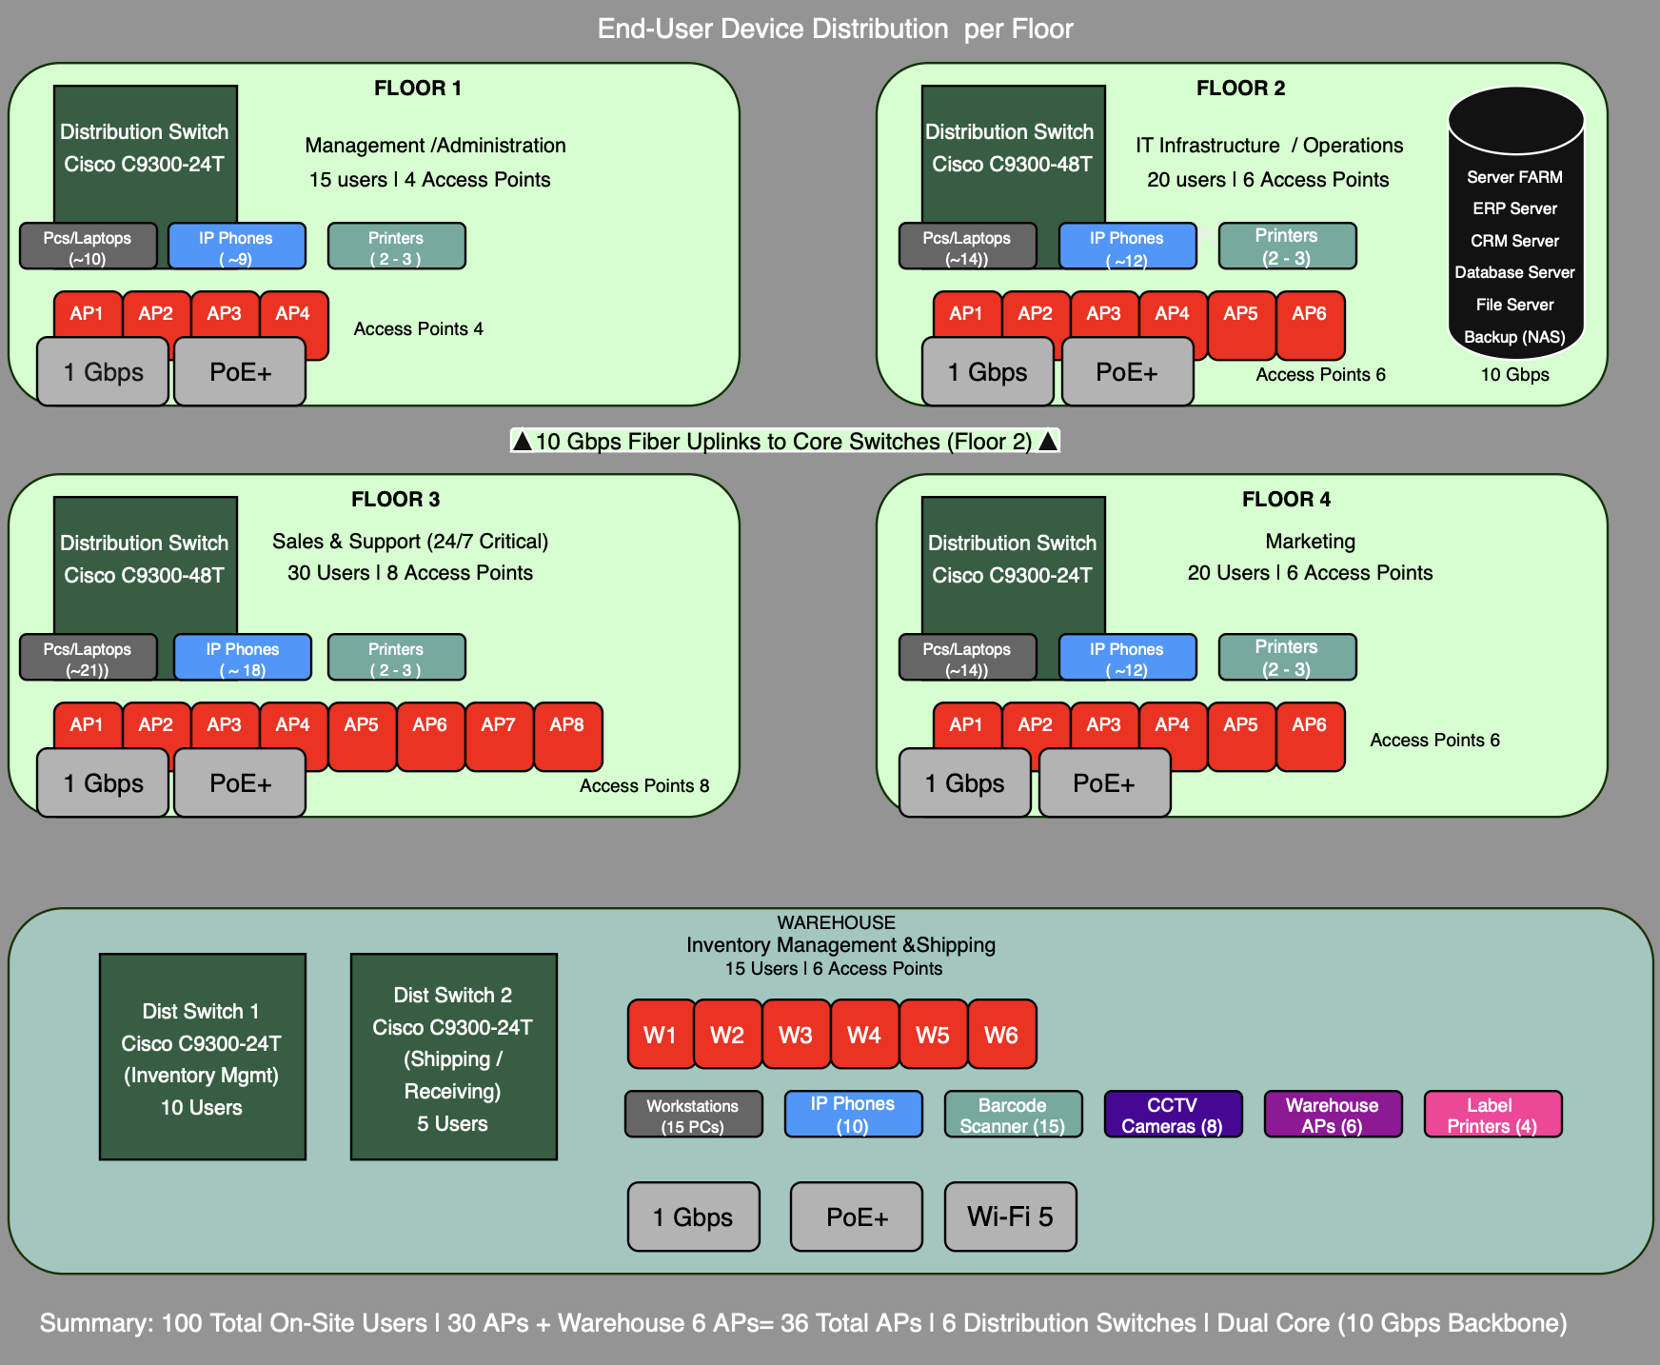

Figure 4. Floor and Warehouse Layout - Distribution Switches, APs, and End-User Connections

Network Equipment Specification
Table 2 specifies all network hardware with estimated prices from UK distributors (Network
Warehouse, 2026; Router-Switch, 2026)
Device | Model | Qty | Spec | Unit Price | Total
Core Switch | Cisco Catalyst  9500-24Y4C | 2 | 24x 1/10/25G + 4x 40/100G | 6,500 | 13,000
Distribution  Switch | Cisco Catalyst  9300-48T | 2 | 48x 1G PoE+, 4x 10G  uplinks | 2,890 | 5,780
Distribution  Switch | Cisco Catalyst  9300-24T | 4 | 24x 1G PoE+, 4x 10G  uplinks | 2,224 | 8,896
Firewall (HA  Pair) | Cisco ASA 5525-X | 2 | 1 Gbps throughput, IPS,  VPN | 5,340 | 10,680
Edge Router | Cisco ISR 4331 | 2 | 2 3x GE, 2x NIM, 300 Mbps | 1,066 | 2,132
Wireless AP | Cisco Aironet 2802i | 50 | 802.11ac Wave 2, 4x4  MIMO | 295 | 14,750
WLAN  Controller | Cisco C9800-L | 1 | Manages up to 150 APs | 3,450 | 3,450
UPS (Rack) | APC Smart-UPS  3000VA | 4 | 3000VA/2700W, rack  mount | 1,850 | 7,400
Server Rack  (42U) | APC AR3100 | 3 | 42U, enclosed, cable mgmt | 950 | 2,850
Patch Panel  (48-port) | Cat6a UTP | 12 | 48-port, 1U, Cat6a rated | 85 | 1,020
Fiber Cable  (10G) | OM4 Multimode | 600  m | 50/125um, 10 Gbps rated | 4.50/m | 2,700
Copper Cable  (Cat6a) | UTP Cat6a | 300  0m | 10 Gbps, 500 MHz rated | 1.20/m | 3,600

Table 2. Network Equipment and Cabling Specification (Prices in GBP, excl. VAT)
Total estimated CapEx for network hardware and cabling is approximately 76,258 GBP, covering all active equipment and physical infrastructure for the four-floor office and warehouse.

Task 2: Network Restructuring Plan
Floor 3 (Sales/Support, 90 employees) and Level 4 (Marketing) will become fully remote while ensuring that standards are met. up porting simultaneous video, CRM, and VoIP require 80/20 Mbps bandwidth and <30ms latency (Ofcom, 2025). The best solution would be FTTP with maximum bandwidth of 900 Mbps from BT Business and Vodafone (BT Business, 2024; Vodafone UK, 2024). FTTC is another option if no FTTP is available, which is at a rate of 80/20 Mbps. Figure 5 illustrates the remote connection design, incorporating cloud and VPN access for ERP systems (Ofcom, 2025).

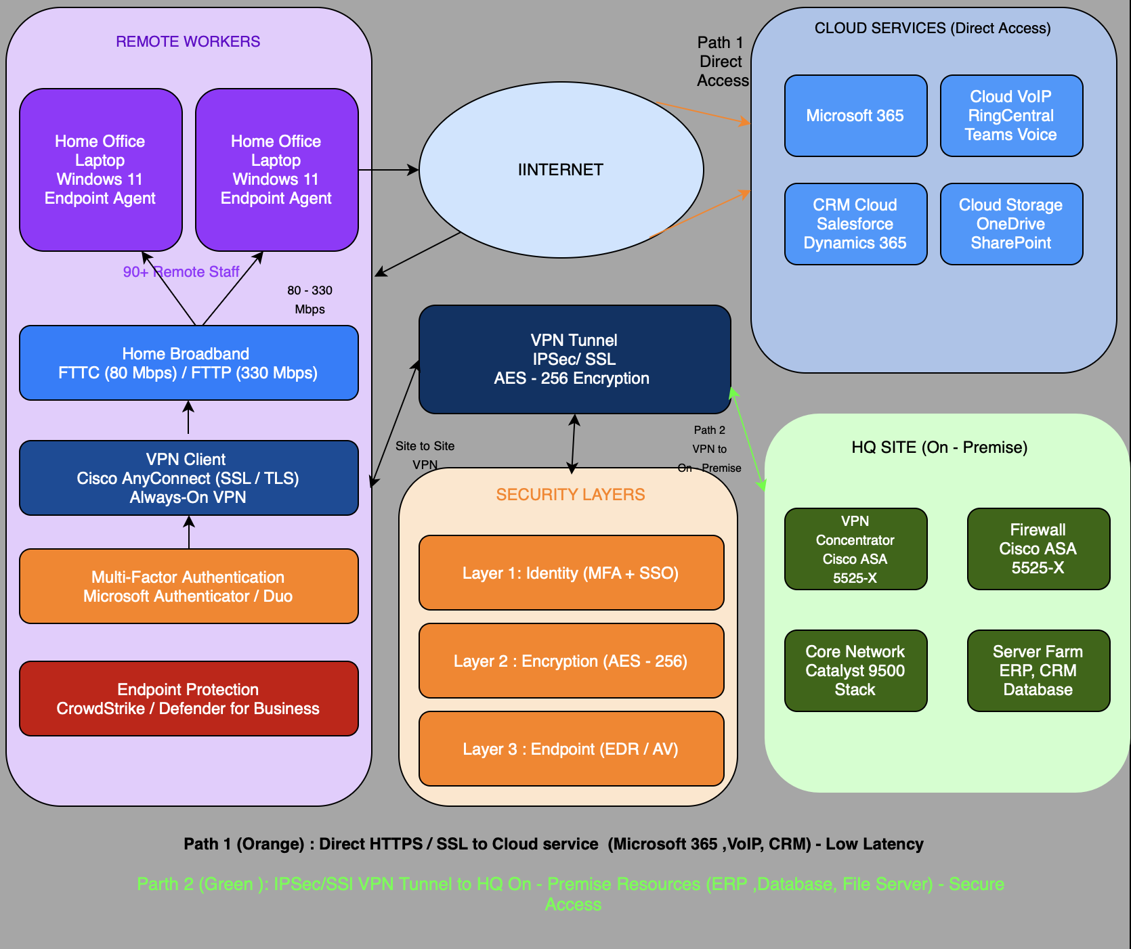
Tech & Co – Remote Connectivity Model
Figure 5. Remote Connectivity Model - VPN and Cloud Access Architecture

2.1 Computing Infrastructure Minimization
Non-critical services are shifted to cloud services – email to Microsoft 365, VoIP to Microsoft Teams, CRM to Salesforce, and files to SharePoint and OneDrive. Microsoft 365 Business Premium license per 135 users will cost approx. 4,852 GBP/month (Microsoft, 2026).
Infrastructure for networking involves two 1 Gbps leased lines with SD-WAN for traffic optimization. Security utilizes split-tunneling VPN, MFA, endpoint security, and zero-trust. Redundancy includes dual-ISP failover, redundant VPNs, and Azure-based disaster recovery (Microsoft Azure, 2026).

2.2 Revised Onsite Infrastructure
On the first floor, there will be limited onsite IT infrastructure for hybrid management. The second floor will continue as a main data center for server, networking, and security infrastructure. On the third and fourth floor, infrastructure is decommissioned with removal of equipment. Warehouse functions remain intact. See Figure 6 below.

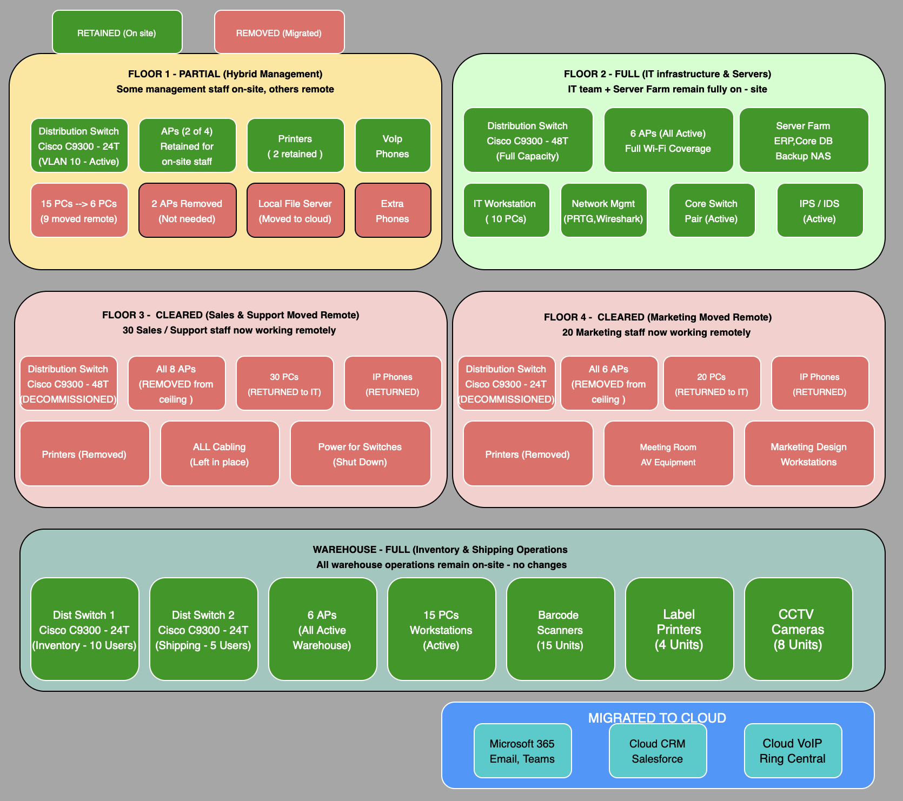
Tech & Co – Minimized On-Site Infrastructure

Figure 6. Minimized On-Site Infrastructure - Retained vs Removed Components
Component | Action | Justification
Core Switches (2x C9500) | Retained | Essential backbone for on-site traffic and server connectivity
Server Farm/ERP | Retained  On-Premis | Management requirement: sensitive data remains on-site for compliance.
Firewalls (2x ASA 5525-X) | Retained | Security perimeter; manages DMZ and VPN termination.
Floor 3 Dist. Switch | Redeployed | Floor 3 vacated; switch moved to warehouse for redundancy.
Floor 4 Dist. Switch | Decommissioned | Floor 4 vacated; excess capacity.
18x Wireless APs | Redeployed | 6 to remote offices; 4 to warehouse; others stored.
Email Server | Cloud Migration | M365 Exchange Online; increases reliability and mobile access.
VoIP PBX | Cloud Migration | Cloud-based Teams Phone; enables remote call handling.
CRM Server | Cloud Migration | Salesforce Cloud; real-time collaboration for distributed teams.
File Server | Cloud Migration | SharePoint/OneDrive; secure remote access and version control.
WLAN Controller | Retained | Manages 32 remaining on-site APs.

Table 3. Equipment Retention, Removal, and Cloud Migration Plan

2.3 Implementation Action Plan (Source: Tanenbaum and Wetherall, 2011)
Phase | Timeline | Key Tasks
1 | W1–3 | Deploy M365, Teams Phone, and Salesforce CRM.
2 | W4–6 | Configure redundant VPN/split tunneling; issue MFA laptops
3 | W7–9 | Cloud migration, stress-testing, and staff training.
4 | W10–12 | Decommission Floors 3-4; hardware redistribution; validation.
Table 4. Implementation Action Plan

Task 3: Final Network Design and Cost Evaluation

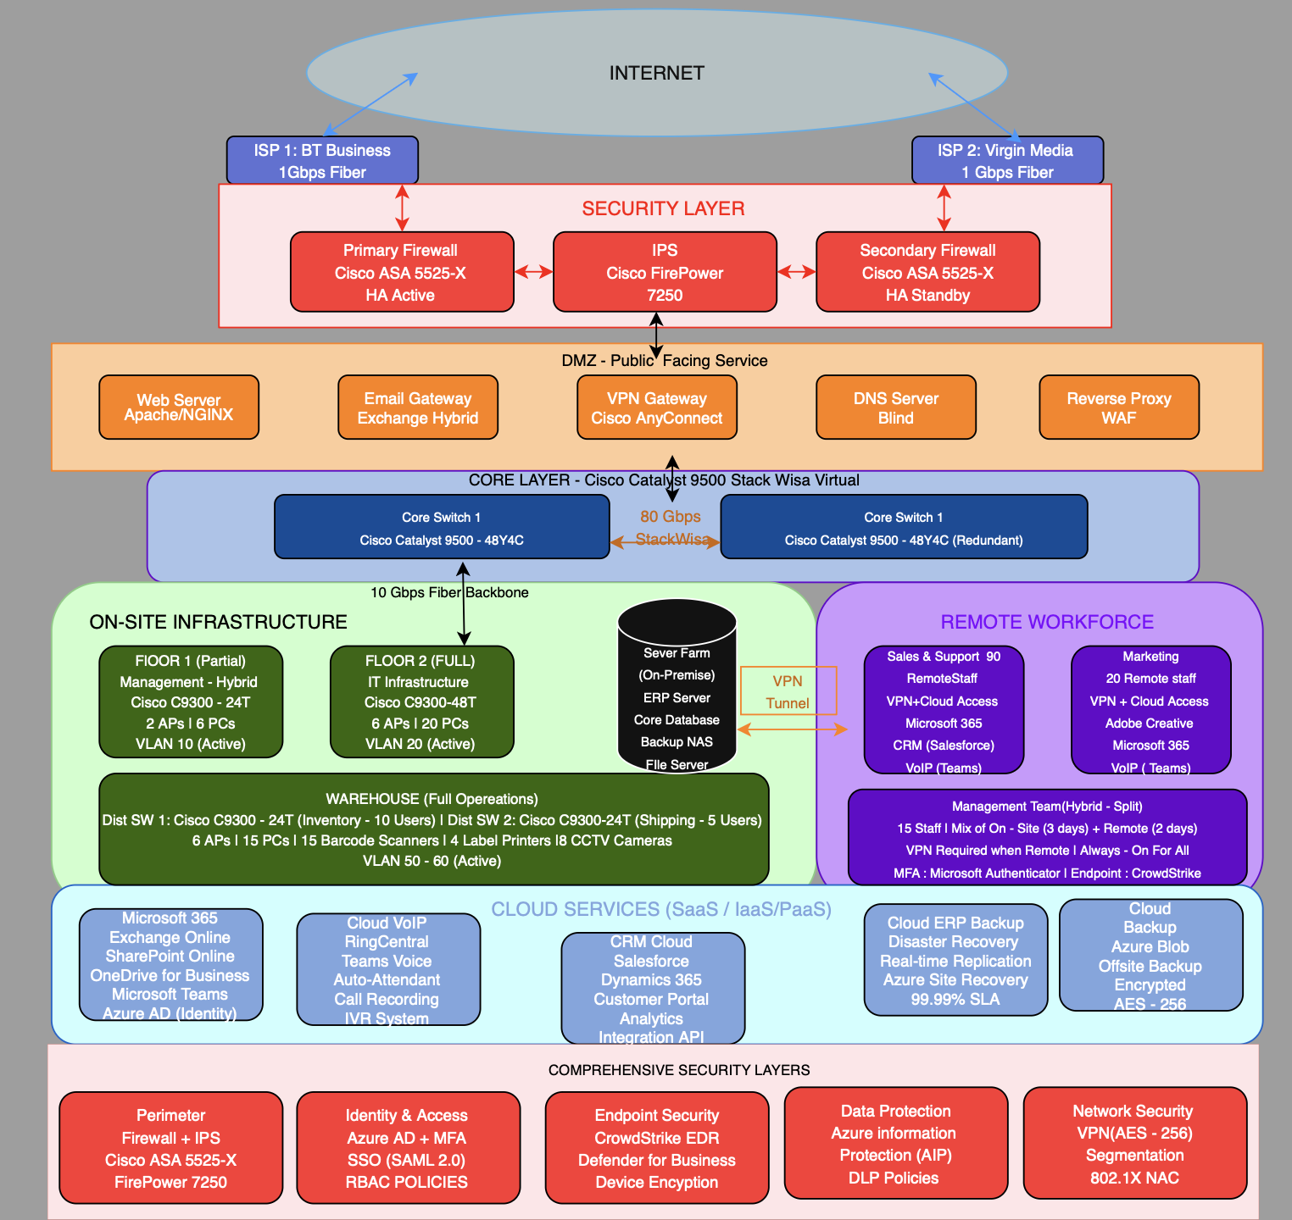
Tech & Co – Remote Connectivity Model

Figure 7. Final Integrated Network Design - Recommended Architecture for Tech and Co.

Detailed Cost Breakdown
Table 5 presents the cost breakdown segmented into CapEx and OpEx, sourced from UK distributors and providers as of March 2026.

Category | Item | Type | Cost (GBP) | Source
Network  Hardware | Core Switches (2x C9500) | CapEx | 13,000 | Network Warehouse, 2026
Network  Hardware | Distribution Switches (4x  C9300) | CapEx | 10,476 | Network Warehouse, 2026
Network  Hardware | Firewalls (2x ASA 5525-X) | CapEx | 10,680 | IT Price, 2026
Network  Hardware | Routers (2x ISR 4331) | CapEx | 2,132 | Router-Switch, 2026
Network  Hardware | WLAN Controller + 32 APs | CapEx | 12,890 | Amazon UK, 2026
Infrastructure | UPS, Racks, Patch Panels | CapEx | 11,270 | APC, 2026
Cabling | Fiber + Copper cabling | CapEx | 4,800 | Estimated
Remote  Equipment | 135x Laptops + Headsets | CapEx | 67,500 | Dell/HP Business, 2026
Internet | Dual 1 Gbps Leased Lines | OpEx/yr | 14,400 | BT Business, 2026
Cloud Services | Microsoft 365 E5 (135 users) | OpEx/yr | 58,224 | Microsoft, 2026
Cloud Services | Salesforce CRM (90 licenses) | OpEx/yr | 10,800 | Salesforce, 2026
Cloud Services | Azure VPN Gateway + DR | OpEx/yr | 4,200 | Azure Pricing, 2026
Security | CrowdStrike EDR (135 users) | OpEx/yr | 7,290 | CrowdStrike, 2026
Support | Cisco SmartNet (4yr contract) | OpEx/yr | 6,500 | Cisco, 2026
Remote  Broadband | Staff broadband subsidy (135) | OpEx/yr | 38,880 | BT/Vodafone, 2026

Table 5. Detailed Cost Breakdown - CapEx and OpEx

Total Cost of Ownership (TCO) Analysis
Cost Category | Year 1 | Year 2 | Year 3 | 3-Year Total
CapEx | 132,748 | 0 | 0 | 132,748
OpEx | 139,294 | 139,294 | 139,294 | 417,882
Total Annual Cost | 272,042 | 139,294 | 139,294 | 550,630
Annual Savings | -18,000 | -72,000 | -72,000 | -162,000
Net Cost | 254,042 | 67,294 | 67,294 | 388,630

Table 6. Three-Year Total Cost of Ownership (TCO) Summary (GBP)

This solution supports doubling turnover to £8M by enabling scalable remote operations and reducing fixed costs, improving flexibility and profit margins (Forrester Research, 2024).

Task 4: Risk-Benefit Analysis and Return on Investment

4.1 Technical Threats
Remote access increases the susceptibility to phishing and ransomware. Defense-in-depth security strategy is adopted to combat this using next generation firewalls, CrowdStrike EDR and multifactor authentication (ISO 27001, 2022). Availability is maintained through dual-ISP failover and redundant VPN connections and the scalability feature offered by Cisco's system architecture at up to £8 million.

4.2 Threats to the Business
Disruption during peak hours could result in losses of approximately £44,000 per hour. This is averted by cloud continuity and geographic dispersion. Financial risks are mitigated through contingency reserves and service level agreements (SLAs). Staff adoption risks are averted by the phased implementation strategy and training. (Kumar et al., 2023).

4.3 Key benefit
Finances: Saving of £72,000 annually starting from Year 2 owing to consolidated offices and decreased energy/IT staff costs.
Operation: Cloud infrastructure improves business continuity and supports continuous operations.
Strategic Advantage: The zero-trust cybersecurity approach provides stronger security compared to traditional on-premises models. The ability to work remotely enables hiring of top-notch employees and 24/7 business operation.

4.4 ROI Analysis
Considering the net investment in three years of £226,630 and an annual income goal of £800,000, any extra 5% income from IT operations will mean an extra £40,000 per year. Although ROI remains negative over three years, long-term benefits such as scalability, cost reduction, and workforce flexibility are expected to achieve break-even within 4–5 years.

References
Amazon UK (2026) Cisco Aironet 2802i Access Point. Available at: https://www.amazon.co.uk/dp/B01HZAMJFG
(Accessed: 15 March 2026).

APC (2026) Smart-UPS 3000VA Rack Mount Specifications. Available at: https://www.apc.com (Accessed: 15 March
2026).

BT Business (2026) Business Fiber Broadband. Available at: https://business.bt.com (Accessed: 10 March 2026).

Cisco Systems (2024a) Enterprise QoS Solution Reference Network Design Guide. San Jose: Cisco Systems.

Cisco Systems (2024b) Cisco Catalyst 9500 Series Data Sheet. Available at:
https://www.cisco.com/c/en/us/products/collateral/switches/catalyst-9500-series-switches (Accessed: 12 March
2026).

CrowdStrike (2026) Falcon Endpoint Protection Pricing. Available at: https://www.crowdstrike.com (Accessed: 14
March 2026).

Forrester Research (2024) The Total Economic Impact of Hybrid Work Infrastructure. Cambridge, MA: Forrester
Research.

Intelligent Servers UK (2026) Cisco Catalyst 9300 Switches. Available at: https://intelligentservers.co.uk (Accessed: 12
March 2026).

ISO (2022) ISO/IEC 27001:2022 Information Security Management Systems. Geneva: International Organization for Standardization.

IT Price (2026) Cisco Global Price List. Available at: https://itprice.com (Accessed: 12 March 2026).

Kashyap, A. and Verma, S. (2023) ‘Impact of COVID-19 on enterprise IT infrastructure’, International Journal of Network Management, 33(2), pp. 1-15.

Kumar, R., Sharma, A. and Patel, V. (2023) ‘Risk assessment in cloud migration strategies for SMEs’, Journal of Cloud Computing, 12(1), pp. 45-62.

Lammle, T. (2021) CompTIA Network+ Certification All-in-One Exam Guide. 5th edn. New York: McGraw-Hill.

Microsoft (2026) Microsoft 365 Business Pricing. Available at:
https://www.microsoft.com/en-us/microsoft-365/business (Accessed: 10 March 2026).

Microsoft Azure (2026) VPN Gateway Pricing. Available at:
https://azure.microsoft.com/en-us/pricing/details/vpn-gateway (Accessed: 14 March 2026).

Network Warehouse (2026) Cisco Catalyst 9300 Series Switches. Available at: https://networkwarehouse.co.uk
(Accessed: 12 March 2026).

Ofcom (2025) UK Home Broadband Performance Report. London: Ofcom.

Oppenheimer, P. (2010) Top-Down Network Design. 3rd edn. Indianapolis: Cisco Press.

Router-Switch (2026) Cisco ISR 4331 Price. Available at: https://www.router-switch.com (Accessed: 12 March 2026).

Salesforce (2026) Salesforce CRM Pricing. Available at: https://www.salesforce.com/uk/pricing (Accessed: 14 March 2026).

Tanenbaum, A.S. and Wetherall, D.J. (2011) Computer Networks. 5th edn. Harlow: Pearson Education.

Vodafone UK (2026) Business Broadband Deals. Available at: https://www.vodafone.co.uk/business (Accessed: 10 March 2026).

